Beauty is our passion, responsibility our mission: Platform TRASH2TREASURE supports upcycling movement and connects consumers, creatives and producers.

Our heart beats for the "we" and drives us to make every area a little better every day. We shape the today and tomorrow to the best of our ability and wherever we can influence. Our goal: we want to change the perception of waste and maintain the value of resources.

It starts with us: Initiated and supported by cosnova beauty and together with the design agency Age5 we have thought about ways how to further utilize products that eventually become waste. As an outcome we initiated a up-cycling workshop where we invited several Berlin based design studios to tackle the waste challenges.
One of the first design solutions from the up-cycling workshop which are showcased to the public is GLACIER a new material developed by the design studio llot llov, the material is made from rejected nail-polish bottles which are crushed and combined with a marble mixture. This new interpretation of colourful terrazzo comes into being, a material that can be used in the kitchen, like shelves, in a bar or on the floor.
The material has been showcased in form of the dining table BOB and the low table BOBBY, as well as the lamp 25/25, during the MAISON&OBJET in January 2019 in Paris where it gained huge attention and amazing feedback from designers and architects.
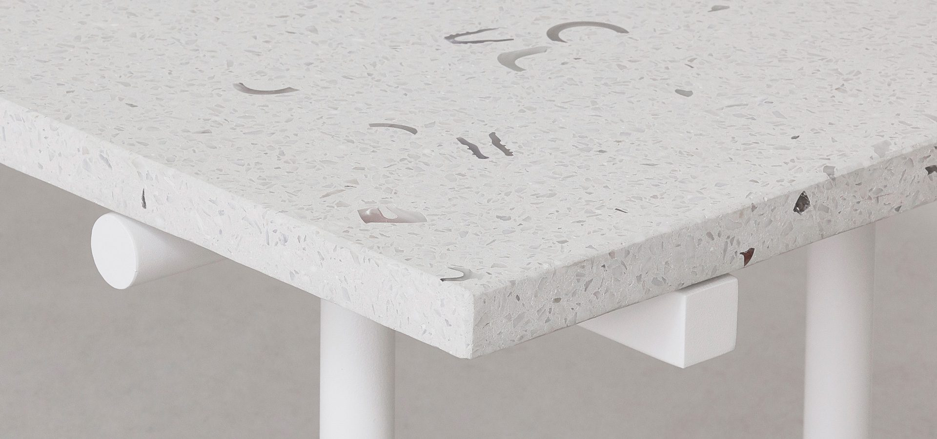
And we're already entering the next level: The possibilities of potential ideas on how to use leftovers, packaging and other types of industrial waste are endless. Due to the increasing global awareness for climate issues and sustainability Up-cycling has become a mega-trend, with a huge movement of individuals.
The new platform TRASH2TREASURE will support this movement by offering not only a place where ideas can mingle and merge, but also a space where producers, creatives and consumers will find support, inspiration, access to up-cyclable material and in a next step upcycling design pieces to purchase.
We are connecting waste (producers) and treasure (designers and creatives).

TRASH2TREASURE will go online in early April 2019.
For the launch of the site, there will be a series of workshops at the largest and most important furniture fair in the world: the Salone del Mobile from April 9-15 2019 in Milan.
The TRASH2TREASURE LAB SPACE in Lambrate Design District will feature internationally renowned designer like Axel Kufus (Universität der Künste Berlin), Osko und Deichmann, Georg Dwalischwili, Fionn Dobbin and llot llov (more to come) with workshops on sustainability and upcycling. The detailed program and the opportunity to register will be open from March 1st at trash2treasure.eu/thelab:
- Upcycling Challenges for designers
- Masterclasses and lectures for Professionals
- Lectures and DIY workshops for the public
- Networking events

ABOUT COSNOVA BEAUTY cosnova Beauty is headquartered in Sulzbach, Germany and is run by the general management Christina Oster-Daum, Javier González, Mathias Delor, Hilko Prahl and Dirk Lauber. At the end of the 2017 fiscal year, cosnova Beauty had around 500 employees. The three cosmetic brands essence, CATRICE, and L.O.V are sold in over 80 countries in Europa, North and South America, in the Middle East, in Asia, Oceania, and Africa. Its customers include drugstores, supermarkets, department stores, perfume shops, and fashion chains.

Contact for TRASH2TREASURE: Astrid Haury | adie@trash2treasure.eu | +49 (0)160 5388445
Contact for PR & Media inquiries: cosnova beauty | Burcu Koc | b.koc@cosnova.com | +49 (0)6196751560

