PRESS RELEASE

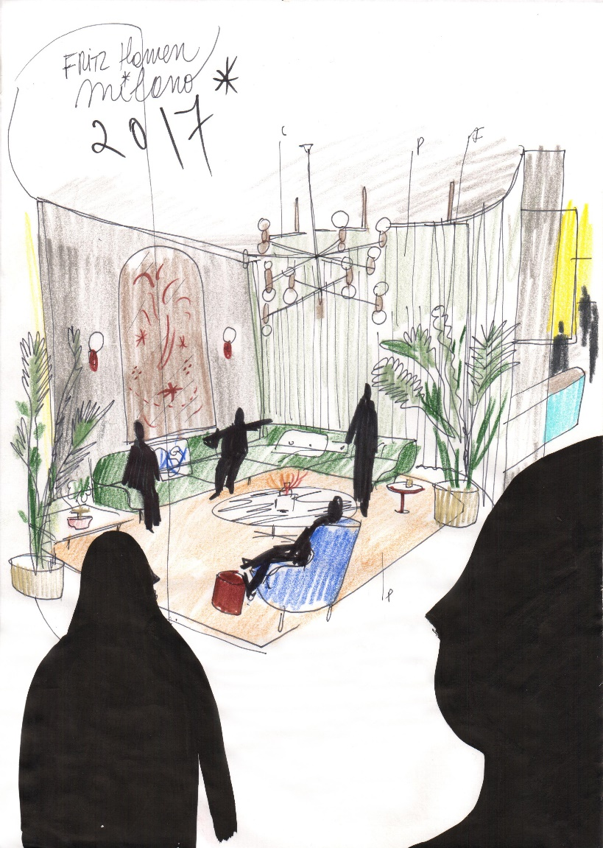

Fritz Hansen presents “Fritz Hotel”

At this year’s Salone Del Mobile in Milan, opposites attract when Republic of Fritz Hansen™ invites you to experience a tropical version of the Nordic aesthetics. Curated by the Spanish designer Jaime Hayon the imaginary hotel lobby of "Fritz Hotel” will set the scene when Fritz Hansen launches their new product designed by Jaime Hayon.

In the lobby, you will meet classic Fritz Hansen pieces dressed especially for the occasion and experience Danish “hygge” when you meet the new member of the Fritz Hansen family. As a sponsor of the world-renowned museum of modern art, Louisiana, Fritz Hansen will also feature an exclusive video installation from the museum’s collection when we open the doors to our imaginary world at the Fritz Hotel. We look forward to seeing you there!

Fritz Hotel
Via San Carpoforo 9

Opening hours:
Tuesday April 4th – Friday April 7th 10am – 8pm
Press conference: Wednesday April 5th at 4pm

For further information, please contact:

HEAD OFFICE PR CONTACT:
THE JOURNAL
Rikke Glad Kirstein
Rikke@thejournal.nu
Tel: (+45) 2390 3210

NORDIC
Sidse Møller Morgenthaler
sim@fritzhansen.com
Tel: (+45) 2519 0770

CENTRAL EUROPE
Jan Frederik Rees
jfr@fritzhansen.com
Tel: (+49) 173 204 88 50

UK
Kalina Kalarus
kkal@fritzhansen.com
Tel: (+44) 7474 060 607

FRANCE
Agence 14 Septembre
Charlotte Rivier
charlotterivier@14septembre.fr
Tel: (+33) 1 55 28 38 28

BENELUX
oona
Viktoria De Cubber
viktoria@oona.be
Tel: (+32) 49 49 82 144

ITALY
Press Office Roberta Eusebio
Veronica Valenza
info@robertaeusebio.it
Tel: (+39) 02 20404989

NORTH-AMERICA
Karolina Dabo
kad@fritzhansen.com
Tel: (+1) 516.702.7663

JAPAN & ASIA PACIFIC
Mayuko Aizawa
maa@fritzhansen.com
Tel: : (+81) 3 5778 3100

Republic of Fritz Hansen™ is an exclusive brand founded in Denmark in 1872 with the mission of crafting timeless design. Fritz Hansen is based in Denmark with concept stores around the world. The Fritz Hansen collection consists of world-famous classics and contemporary products, all made in collaboration with leading international designers such as Arne Jacobsen, Poul Kjærholm, Piero Lissoni, Kasper Salto and Jaime Hayon, with more to come. In 2015 Fritz Hansen launched its first collection of accessories, Objects, consisting of beautiful designs from both Danish and international designers to fit the home. The same year Fritz Hansen acquired LIGHTYEARS, which offers contemporary Danish design lamps and focuses on bringing a combination of light and beauty into people’s everyday lives. The collection is created in collaboration with Danish and international designers such as Cecilie Manz, GamFratesi, Jo Hammerborg, Iskos-Berlin, KiBiSi, Jørn Utzon and Christian Dell. At Fritz Hansen, we believe that a single piece of furniture can beautify an entire room or building – and the minds of the people who live or work there. We aim to design beautiful furniture without compromising on comfort. It is our ambition to become a niche company in the absolute global elite in the field of design, luxury and lifestyle.

